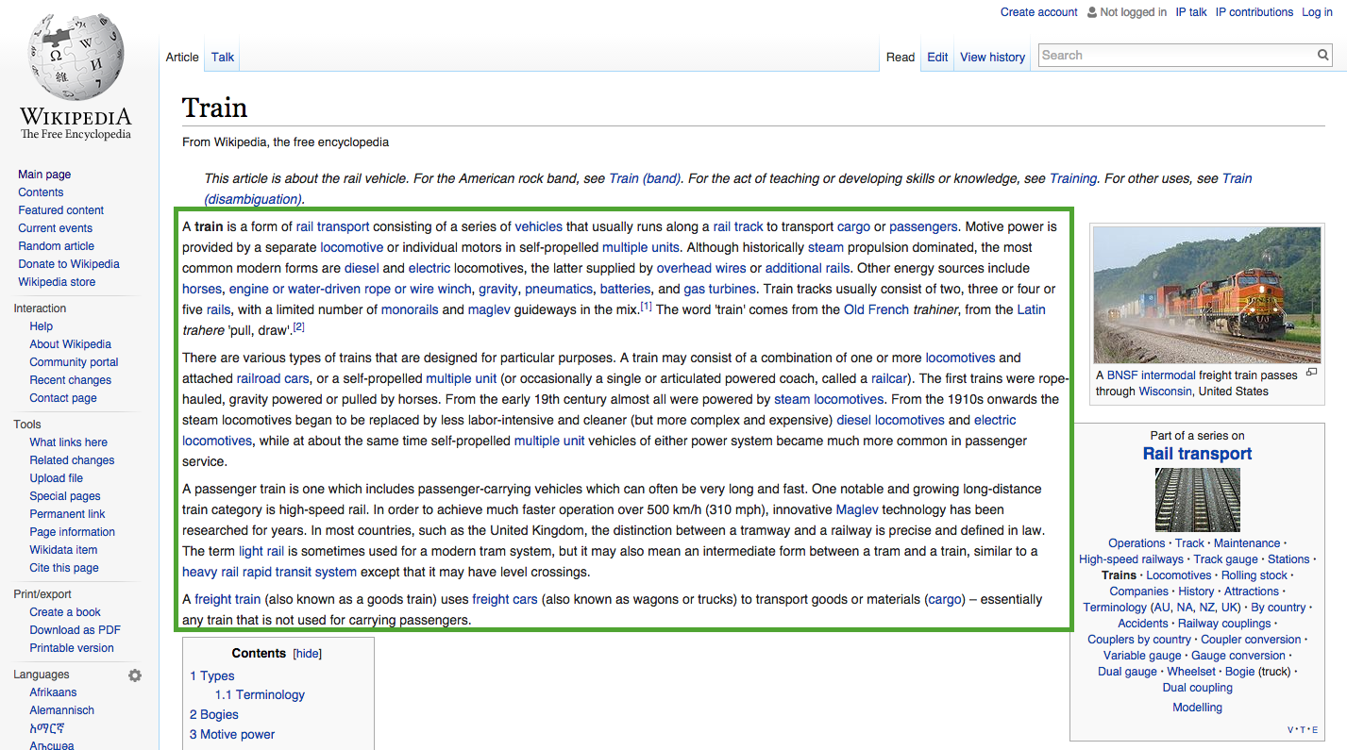**First Link Path to Philosophy**

starting with “Train”

Train

⇓

Rain Transport

⇓

Conveyance of Passengers and Goods

⇓

Goods

⇓

Economics

⇓

Social Science

⇓

Academic Disciplines

⇓

Knowledge

⇓

Awareness

⇓

Consciousness

⇓

Quality

⇓

Philosophy